

|  |  |  |
| --- | --- | --- |
| Name:  MUHAMMAD ALIF SERBAINI | | |
| ID Number: AM2111010447 | | |
| Lecturer  WAN ASIAH BT WAN MUHAMAD TAHIR | | Lab group / Tutorial group / Tutor (if applicable) |
| Course and Course Code  DATA STRUCTURE SWC3344 | | Submission Date:  Week 7 |
| Assignment No. / Title  ASSIGNMENT | | Extension & Late submission: Allowed / Disallowed |
| Assignment type:  INDIVIDUAL | % of Assignment Mark  / | Returning Date: |
| Penalties:   1. 10% of the original mark will be deducted for every one week period after the submission date 2. No work will be accepted after two weeks of the deadline 3. If you were unable to submit the coursework on time due to extenuating circumstances you may be eligible for an extension 4. Extension will not exceed one week | | |
| Declaration: I/we the undersigned confirm that I/we have read and agree to abide by these regulations on plagiarism and cheating. I/we confirm that this piece of work is my/our own.  I/we consent to appropriate storage of our work for checking to ensure that there is no plagiarism/ academic cheating.  Signature:  Full Name:MUHAMMAD ALIF SERBAINI | | |
| This section may be used for feedback or other information | | |

## Table of Content

Contents

1.0 Table of Content 2

2.0 Introduction 2

3.0 Design 2

4.0 Reflective Conclusion 3

Appendix 1 3

Appendix 2 7

Appendix 3 : Rubric 38

2.0 Introduction

This assignment is assigned to us from Madam Wan Asiah on the 24 August 2022 and the assignment is about an arrayList program to help with the Parcels at a Courier Service. This program is created with effiency in mind. It is created for the J&V Express Courier Services because they are still storing their file in a traditional way which is in a book with lots of pages that needs to be looked at one by one manually. This can slow down the processs of entering a new Parcel data by a lot. This new way using arraylist will cut down the time by storing the data into a .txt file which is named Courier.txt. in our final output it currently have 25 Parcels data that is ready be displayed or tinkered with. Using the Menus that is also coded into this program such as add, update, delete, display. There is a class called *ParcelInformation* and it contains the following attributes :

1. Tracking number
2. Sender Name
3. Recipient Name
4. Sender Address
5. Recipient Address
6. Postcode to
7. Postcode from
8. Parcel weight
9. Parcel length
10. Parcel height
11. Shipping Type
12. Parcel Type
13. Shipping category
14. Shipping date
15. Delivery date

## 3.0 Design

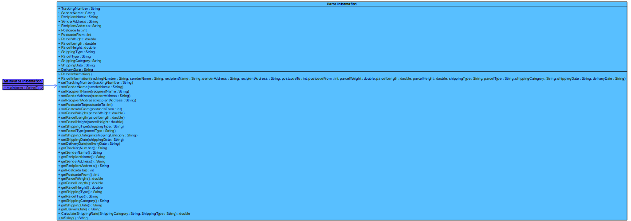

## 4.0 Reflective Conclusion

The things that I learned from this task that was given by Madam wan Asiah, I learn that Arraylist is kind of similar to the traditional array but not one to one kind of similarity. Sometimes Arraylist have an advantage where it is not a fixable variable length while Array is, which makes it more if you want to insert more data on the fly without changing the Array size like you did on a Normal Array.

I got very confused on how to continue making a submenu within a menu at first glance because there’s just too many variables for my brain to handle. I also got confused on the FileReader/BufferedReader part because I got stuck there for a long time because I forgot to add enough data so I got error such as wrong data type. Entering 25 data manually where it is just not random and need to have delimeter is very brain wrecking moment for me.

## Appendix 1

Coding for **ParcelInformation.java**

public class ParcelInformation {  
  
 String TrackingNumber;  
 String SenderName;  
 String RecipientName;  
 String SenderAddress;  
 String RecipientAddress;  
 int PostcodeTo;  
 int PostcodeFrom;  
 double ParcelWeight;  
 double ParcelLength;  
 double ParcelHeight;  
 String ShippingType;  
 String ParcelType;  
 String ShippingCategory;  
 String ShippingDate;  
 String DeliveryDate;  
  
 ParcelInformation(){  
  
 }  
  
 public ParcelInformation(String trackingNumber, String senderName, String recipientName, String senderAddress, String recipientAddress, int postcodeTo, int postcodeFrom, double parcelWeight, double parcelLength,  
 double parcelHeight, String shippingType, String parcelType, String shippingCategory, String shippingDate, String deliveryDate) {  
 TrackingNumber = trackingNumber;  
 SenderName = senderName;  
 RecipientName = recipientName;  
 SenderAddress = senderAddress;  
 RecipientAddress = recipientAddress;  
 PostcodeTo = postcodeTo;  
 PostcodeFrom = postcodeFrom;  
 ParcelWeight = parcelWeight;  
 ParcelLength = parcelLength;  
 ParcelHeight = parcelHeight;  
 ShippingType = shippingType;  
 ParcelType = parcelType;  
 ShippingCategory = shippingCategory;  
 ShippingDate = shippingDate;  
 DeliveryDate = deliveryDate;  
 }  
  
 public void setTrackingNumber(String trackingNumber) {TrackingNumber = trackingNumber;}  
 public void setSenderName(String senderName) {SenderName = senderName;}  
 public void setRecipientName(String recipientName) {RecipientName = recipientName;}  
 public void setSenderAddress(String senderAddress) {  
 SenderAddress = senderAddress;}  
 public void setRecipientAddress(String recipientAddress) {  
 RecipientAddress = recipientAddress;}  
 public void setPostcodeTo(int postcodeTo) {PostcodeTo = postcodeTo;}  
 public void setPostcodeFrom(int postcodeFrom) {PostcodeFrom = postcodeFrom;}  
 public void setParcelWeight(double parcelWeight) {ParcelWeight = parcelWeight;}  
 public void setParcelLength(double parcelLength) {  
 ParcelLength = parcelLength;}  
 public void setParcelHeight(double parcelHeight) {ParcelHeight = parcelHeight;}  
 public void setShippingType(String shippingType) {ShippingType = shippingType;}  
 public void setParcelType(String parcelType) {ParcelType = parcelType;}  
 public void setShippingCategory(String shippingCategory) {ShippingCategory = shippingCategory;}  
 public void setShippingDate(String shippingDate) {ShippingDate = shippingDate;}  
 public void setDeliveryDate(String deliveryDate) {DeliveryDate = deliveryDate;}  
  
 public String getTrackingNumber() {return TrackingNumber;}  
 public String getSenderName() {return SenderName;}  
 public String getRecipientName() {return RecipientName;}  
 public String getSenderAddress() {return SenderAddress;}  
 public String getRecipientAddress() {return RecipientAddress;}  
 public int getPostcodeTo() {return PostcodeTo;}  
 public int getPostcodeFrom() {return PostcodeFrom;}  
 public double getParcelWeight() {return ParcelWeight;}  
 public double getParcelLength() {return ParcelLength;}  
 public double getParcelHeight() {return ParcelHeight;}  
 public String getShippingType() {return ShippingType;}  
 public String getParcelType() {return ParcelType;}  
 public String getShippingCategory() {return ShippingCategory;}  
 public String getShippingDate() {return ShippingDate;}  
 public String getDeliveryDate() {return DeliveryDate;}  
  
 double CalculateShippingRate(String ShippingCategory, String ShippingType) {  
 double ShippingRate = 0;  
 if (ShippingCategory.equalsIgnoreCase("International")) {  
 ShippingRate = ParcelWeight * 50.00;  
 }  
 if (ShippingCategory.equalsIgnoreCase("Domestic")) {  
 ShippingRate = ParcelWeight * 7.00;  
 }  
 if(ShippingType.equalsIgnoreCase("Next day Delivery") && ShippingCategory.equalsIgnoreCase("Domestic")) {  
 ShippingRate = ParcelWeight * 7.00 + 10.00;  
 }  
 return ShippingRate;  
 }  
  
 public String toString() {  
 return "\n\nParcelInformation{" +  
 "\nTrackingNumber ='" + getTrackingNumber() + '\'' +  
 "\nSender Name ='" + getSenderName() + '\'' +  
 "\nRecipient Name ='" + getRecipientName() + '\'' +  
 "\nSenderAddress ='" + getSenderAddress() + '\'' +  
 "\nRecipient Address ='" + getRecipientAddress() + '\'' +  
 "\nPostcode To =" + getPostcodeTo() +  
 "\nPostcode From =" + getPostcodeFrom() +  
 "\nParcel Weight =" + getParcelWeight() +  
 "\nParcel Length =" + getParcelLength() +  
 "\nParcel Height =" + getParcelHeight() +  
 "\nShipping Type ='" + getShippingType() + '\'' +  
 "\nParcel Type ='" + getParcelType() + '\'' +  
 "\nShipping Category ='" + getShippingCategory() + '\'' +  
 "\nShipping Date = '" + getShippingDate() + '\'' +  
 "\nDeliveryDate =" + getDeliveryDate() + "\n\n";  
 }  
}

Coding for MainParcelInformation.java

import javax.swing.*;  
import java.util.StringTokenizer;  
import java.util.ArrayList;  
import java.io.BufferedReader;  
import java.io.FileReader;  
  
  
public class MainParcelInformation {  
 public static void main (String[] args)  
 {  
 try  
 {  
 *//Create FileReader* BufferedReader in = new BufferedReader(new FileReader("Courier.txt"));  
  
 ArrayList<ParcelInformation> ParcelList = new ArrayList<>();  
  
 ParcelInformation ParcelInformation;  
  
 String data = null;  
  
 while((data = in.readLine())!=null)  
 {  
 StringTokenizer st = new StringTokenizer(data, ";");  
 String TrackingNumber = st.nextToken();  
 String SenderName = st.nextToken();  
 String RecipientName = st.nextToken();  
 String SenderAddress = st.nextToken();  
 String RecipientAddress = st.nextToken();  
 int PostcodeTo = Integer.*parseInt*(st.nextToken());  
 int PostcodeFrom = Integer.*parseInt*(st.nextToken());  
 double ParcelWeight = Double.*parseDouble*(st.nextToken());  
 double ParcelLength = Double.*parseDouble*(st.nextToken());  
 double ParcelHeight = Double.*parseDouble*(st.nextToken());  
 String ShippingType = st.nextToken();  
 String ParcelType = st.nextToken();  
 String ShippingCategory= st.nextToken();  
 String ShippingDate = st.nextToken();  
 String DeliveryDate = st.nextToken();  
  
 ParcelInformation = new ParcelInformation(TrackingNumber,SenderName,RecipientName,SenderAddress,RecipientAddress,PostcodeTo,PostcodeFrom,ParcelWeight,ParcelLength,ParcelHeight,ShippingType,ParcelType,ShippingCategory,ShippingDate,DeliveryDate);  
  
 ParcelList.add(ParcelInformation);  
 }  
 in.close();  
  
 int menu = 0;  
 do  
 {  
  
 menu = Integer.*parseInt*(JOptionPane.*showInputDialog*("Please choose the following menu \n Press 1 to Insert Data \n Press 2 to Update the Data \n Press 3 to Remove Data\n Press 4 to Display the Parcels Info Submenu \n Press 5 to Exit the Program"));  
  
 if(menu == 1)  
 {  
 int trackNum = 1025 + 1;  
 String TrackingNumber = "" +trackNum;  
 String SenderName = JOptionPane.*showInputDialog*("Enter Sender Name : ");  
 String RecipientName = JOptionPane.*showInputDialog*("Enter Recipient Name : ");  
 String SenderAddress = JOptionPane.*showInputDialog*("Enter Sender Address : ");  
 String RecipientAddress = JOptionPane.*showInputDialog*("Enter Recipient Address : ");  
 int PostcodeTo = Integer.*parseInt*(JOptionPane.*showInputDialog*("Enter PostCode To : "));  
 int PostcodeFrom = Integer.*parseInt*(JOptionPane.*showInputDialog*("Enter PostCode From : "));  
 double ParcelWeight = Double.*parseDouble*(JOptionPane.*showInputDialog*("Enter Weight of the Parcel : "));  
 double ParcelLength = Double.*parseDouble*(JOptionPane.*showInputDialog*("Enter Length of the Parcel : "));  
 double ParcelHeight = Double.*parseDouble*(JOptionPane.*showInputDialog*("Enter Height of the Parcel : "));  
 String ShippingType = JOptionPane.*showInputDialog*("Enter Shipping Type : ");  
 String ParcelType = JOptionPane.*showInputDialog*("Enter Parcel Type : ");  
 String ShippingCategory = JOptionPane.*showInputDialog*("Enter Shipping Category : ");  
 String ShippingDate = JOptionPane.*showInputDialog*("Enter Shipping Date : ");  
 String DeliveryDate = JOptionPane.*showInputDialog*("Enter Delivery Date : ");  
  
 ParcelInformation = new ParcelInformation(TrackingNumber,SenderName,RecipientName,SenderAddress,RecipientAddress,PostcodeTo,PostcodeFrom,ParcelWeight,ParcelLength,ParcelHeight,ShippingType,ParcelType,ShippingCategory,ShippingDate,DeliveryDate);  
  
 ParcelList.add(ParcelInformation);  
 }  
 else if (menu == 2)  
 {  
  
 String TrackNumb = JOptionPane.*showInputDialog*("Enter The Tracking Number to update the Record's date");  
 for(int i = 0; i<ParcelList.size(); i++)  
 {  
 ParcelInformation = ParcelList.get(i);  
 if(ParcelInformation.getTrackingNumber().equalsIgnoreCase(TrackNumb))  
 {  
 String DeliverDate = JOptionPane.*showInputDialog*("Enter the New Delivery Date");  
 ParcelInformation.setDeliveryDate(DeliverDate);  
 ParcelList.set(i, ParcelInformation);  
 }  
 }  
 }  
 else if (menu == 3)  
 {  
  
 String TrackNumb = JOptionPane.*showInputDialog*("Enter The Tracking Number to Delete The Record's Data");  
 for(int i = 0; i<ParcelList.size(); i++)  
 {  
 ParcelInformation = ParcelList.get(i);  
 if (ParcelInformation.getTrackingNumber().equalsIgnoreCase(TrackNumb));  
 {  
 ParcelList.remove(ParcelInformation);  
 }  
  
 }  
 }  
 else if (menu == 4)  
 {  
 int menu2 = 0;  
 do  
 {  
 menu2 = Integer.*parseInt*(JOptionPane.*showInputDialog*("Choose to Display \n Type 1 : to Display ALL Parcel \n Type 2 : to Display Domestic Only \n Type 3 : to Display International Parcel Only \n Type 4 : to Count Fragile & Non-Fragile Parcel \n Type 5 : to Display Large Parcel (5KG and Above)\n Type 6 : to Display Parcel to Is delivered on the next day \n Type 7 : to go to the Main Menu"));  
  
 if(menu2 == 1)  
 {  
 int x = 1;  
 for(int i = 0; i<ParcelList.size(); i++)  
 {  
 System.out.println(x++ + "" + ParcelList.get(i).toString());  
 }  
 }  
 else if(menu2 == 2)  
 {  
 int y = 1;  
 for(int i = 0; i<ParcelList.size(); i++)  
 {  
 ParcelInformation = ParcelList.get(i);  
 if(ParcelInformation.getShippingCategory().equalsIgnoreCase("Domestic"))  
 {  
 System.out.println(y++ + "" + ParcelList.get(i));  
 }  
 }  
 }  
 else if (menu2 == 3)  
 {  
 int z = 1;  
 for(int i = 0; i<ParcelList.size(); i++)  
 {  
  
 ParcelInformation = ParcelList.get(i);  
 if(ParcelInformation.getShippingCategory().equalsIgnoreCase("International"))  
 {  
 System.out.println(z++ + "" + ParcelList.get(i));  
 }  
 }  
 }  
 else if(menu2 == 4)  
 {  
 int a = 0;  
 int ab = 0;  
 for(int i = 0; i<ParcelList.size(); i++)  
 {  
 ParcelInformation = ParcelList.get(i);  
 if(ParcelInformation.getParcelType().equalsIgnoreCase("Fragile"))  
 {  
 a++;  
 }  
 else if(ParcelInformation.getParcelType().equalsIgnoreCase("Non-Fragile"))  
 {  
 ab++;  
 }  
  
 }  
 System.out.println("Non-Fragile : " + ab++);  
 System.out.println("Fragile : " + a++);  
 }  
 else if(menu2 == 5)  
 {  
 int x = 1;  
 for(int i = 0; i<ParcelList.size(); i++)  
 {  
 ParcelInformation = ParcelList.get(i);  
 if(ParcelInformation.getParcelWeight() > 5.00)  
 {  
 System.out.println(x++ + "" + ParcelList.get(i));  
 }  
 }  
 }  
 else if(menu2 == 6)  
 {  
 int y = 1;  
 for(int i = 0; i<ParcelList.size(); i++)  
 {  
 ParcelInformation = ParcelList.get(i);  
 if(ParcelInformation.getShippingType().equalsIgnoreCase("Next day Delivery"))  
 {  
 System.out.println(y++ + "" + ParcelList.get(i));  
 }  
 }  
 }  
 }while (menu2 != 7);  
 }  
 }while (menu !=5);  
 }  
 catch(Exception ex)  
 {  
 System.out.println(ex.getMessage());  
 }  
  
 }  
}

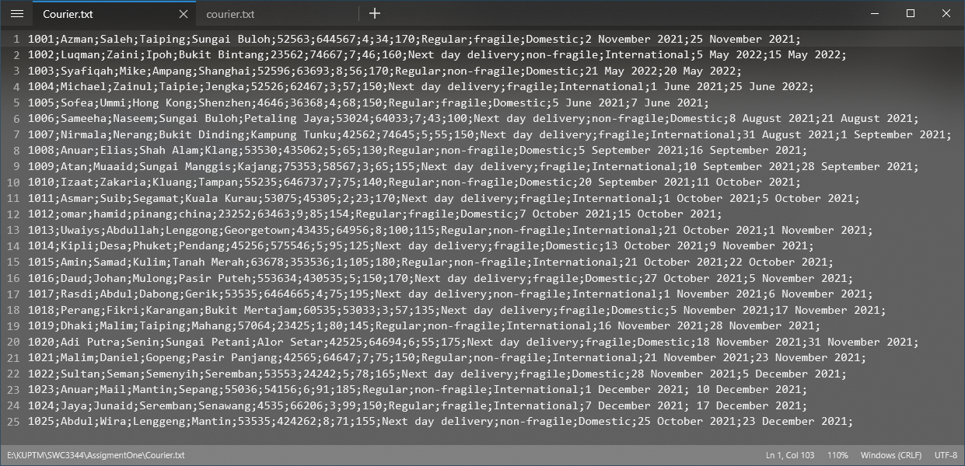

## Appendix 2

Main Menu :

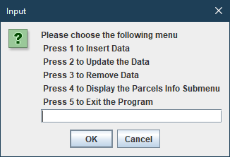

Menu 1. Add new Parcel Data

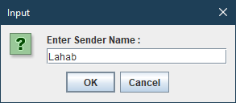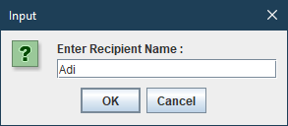

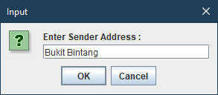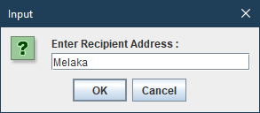

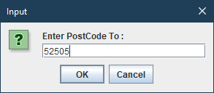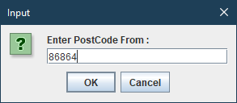

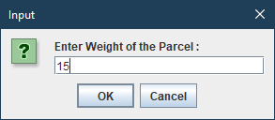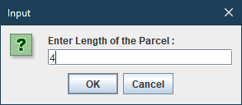

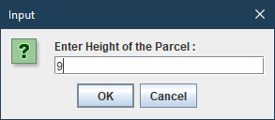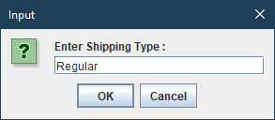

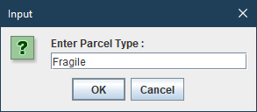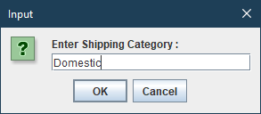

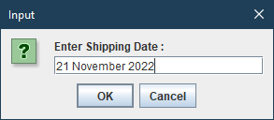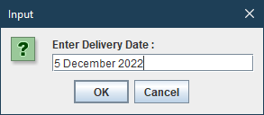

Output for Menu 1 (Add Parcel) :

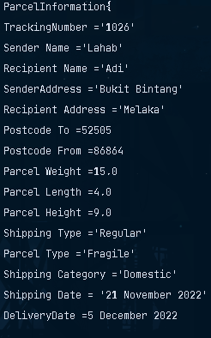

Menu 2 (Update data)

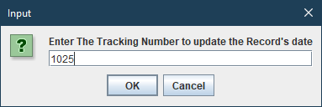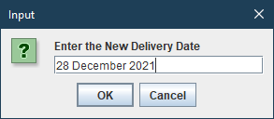

Before :

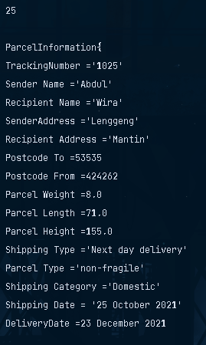

After :

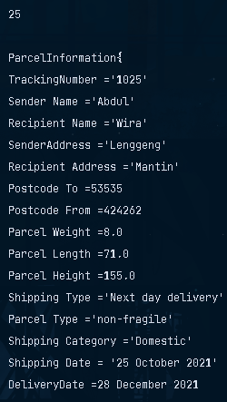

Menu 3 (Delete Data)  
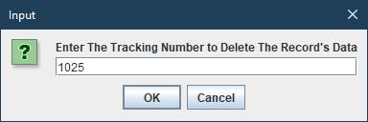

Before : 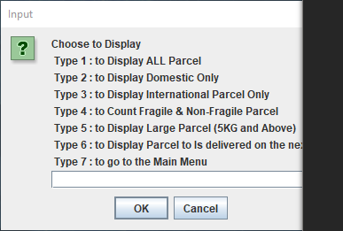

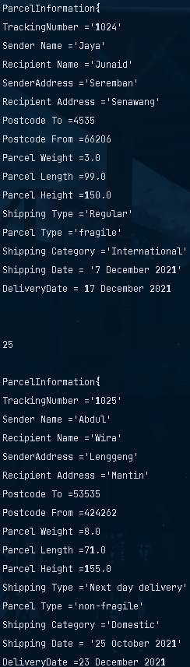

After :

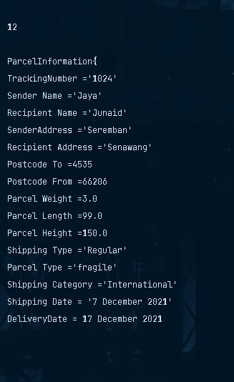

Menu 4 (Display)

1 : Output

1

ParcelInformation{

TrackingNumber ='1001'

Sender Name ='Azman'

Recipient Name ='Saleh'

SenderAddress ='Taiping'

Recipient Address ='Sungai Buloh'

Postcode To =52563

Postcode From =644567

Parcel Weight =4.0

Parcel Length =34.0

Parcel Height =170.0

Shipping Type ='Regular'

Parcel Type ='fragile'

Shipping Category ='Domestic'

Shipping Date = '2 November 2021'

DeliveryDate =25 November 2021

2

ParcelInformation{

TrackingNumber ='1002'

Sender Name ='Luqman'

Recipient Name ='Zaini'

SenderAddress ='Ipoh'

Recipient Address ='Bukit Bintang'

Postcode To =23562

Postcode From =74667

Parcel Weight =7.0

Parcel Length =46.0

Parcel Height =160.0

Shipping Type ='Next day delivery'

Parcel Type ='non-fragile'

Shipping Category ='International'

Shipping Date = '5 May 2022'

DeliveryDate =15 May 2022

3

ParcelInformation{

TrackingNumber ='1003'

Sender Name ='Syafiqah'

Recipient Name ='Mike'

SenderAddress ='Ampang'

Recipient Address ='Shanghai'

Postcode To =52596

Postcode From =63693

Parcel Weight =8.0

Parcel Length =56.0

Parcel Height =170.0

Shipping Type ='Regular'

Parcel Type ='non-fragile'

Shipping Category ='Domestic'

Shipping Date = '21 May 2022'

DeliveryDate =20 May 2022

4

ParcelInformation{

TrackingNumber ='1004'

Sender Name ='Michael'

Recipient Name ='Zainul'

SenderAddress ='Taipie'

Recipient Address ='Jengka'

Postcode To =52526

Postcode From =62467

Parcel Weight =3.0

Parcel Length =57.0

Parcel Height =150.0

Shipping Type ='Next day delivery'

Parcel Type ='fragile'

Shipping Category ='International'

Shipping Date = '1 June 2021'

DeliveryDate =25 June 2022

5

ParcelInformation{

TrackingNumber ='1005'

Sender Name ='Sofea'

Recipient Name ='Ummi'

SenderAddress ='Hong Kong'

Recipient Address ='Shenzhen'

Postcode To =4646

Postcode From =36368

Parcel Weight =4.0

Parcel Length =68.0

Parcel Height =150.0

Shipping Type ='Regular'

Parcel Type ='fragile'

Shipping Category ='Domestic'

Shipping Date = '5 June 2021'

DeliveryDate =7 June 2021

6

ParcelInformation{

TrackingNumber ='1006'

Sender Name ='Sameeha'

Recipient Name ='Naseem'

SenderAddress ='Sungai Buloh'

Recipient Address ='Petaling Jaya'

Postcode To =53024

Postcode From =64033

Parcel Weight =7.0

Parcel Length =43.0

Parcel Height =100.0

Shipping Type ='Next day delivery'

Parcel Type ='non-fragile'

Shipping Category ='Domestic'

Shipping Date = '8 August 2021'

DeliveryDate =21 August 2021

7

ParcelInformation{

TrackingNumber ='1007'

Sender Name ='Nirmala'

Recipient Name ='Nerang'

SenderAddress ='Bukit Dinding'

Recipient Address ='Kampung Tunku'

Postcode To =42562

Postcode From =74645

Parcel Weight =5.0

Parcel Length =55.0

Parcel Height =150.0

Shipping Type ='Next day delivery'

Parcel Type ='fragile'

Shipping Category ='International'

Shipping Date = '31 August 2021'

DeliveryDate =1 September 2021

8

ParcelInformation{

TrackingNumber ='1008'

Sender Name ='Anuar'

Recipient Name ='Elias'

SenderAddress ='Shah Alam'

Recipient Address ='Klang'

Postcode To =53530

Postcode From =435062

Parcel Weight =5.0

Parcel Length =65.0

Parcel Height =130.0

Shipping Type ='Regular'

Parcel Type ='non-fragile'

Shipping Category ='Domestic'

Shipping Date = '5 September 2021'

DeliveryDate =16 September 2021

9

ParcelInformation{

TrackingNumber ='1009'

Sender Name ='Atan'

Recipient Name ='Muaaid'

SenderAddress ='Sungai Manggis'

Recipient Address ='Kajang'

Postcode To =75353

Postcode From =58567

Parcel Weight =3.0

Parcel Length =65.0

Parcel Height =155.0

Shipping Type ='Next day delivery'

Parcel Type ='fragile'

Shipping Category ='International'

Shipping Date = '10 September 2021'

DeliveryDate =28 September 2021

10

ParcelInformation{

TrackingNumber ='1010'

Sender Name ='Izaat'

Recipient Name ='Zakaria'

SenderAddress ='Kluang'

Recipient Address ='Tampan'

Postcode To =55235

Postcode From =646737

Parcel Weight =7.0

Parcel Length =75.0

Parcel Height =140.0

Shipping Type ='Regular'

Parcel Type ='non-fragile'

Shipping Category ='Domestic'

Shipping Date = '20 September 2021'

DeliveryDate =11 October 2021

11

ParcelInformation{

TrackingNumber ='1011'

Sender Name ='Asmar'

Recipient Name ='Suib'

SenderAddress ='Segamat'

Recipient Address ='Kuala Kurau'

Postcode To =53075

Postcode From =45305

Parcel Weight =2.0

Parcel Length =23.0

Parcel Height =170.0

Shipping Type ='Next day delivery'

Parcel Type ='fragile'

Shipping Category ='International'

Shipping Date = '1 October 2021'

DeliveryDate =5 October 2021

12

ParcelInformation{

TrackingNumber ='1012'

Sender Name ='omar'

Recipient Name ='hamid'

SenderAddress ='pinang'

Recipient Address ='china'

Postcode To =23252

Postcode From =63463

Parcel Weight =9.0

Parcel Length =85.0

Parcel Height =154.0

Shipping Type ='Regular'

Parcel Type ='fragile'

Shipping Category ='Domestic'

Shipping Date = '7 October 2021'

DeliveryDate =15 October 2021

13

ParcelInformation{

TrackingNumber ='1013'

Sender Name ='Uwaiys'

Recipient Name ='Abdullah'

SenderAddress ='Lenggong'

Recipient Address ='Georgetown'

Postcode To =43435

Postcode From =64956

Parcel Weight =8.0

Parcel Length =100.0

Parcel Height =115.0

Shipping Type ='Regular'

Parcel Type ='non-fragile'

Shipping Category ='International'

Shipping Date = '21 October 2021'

DeliveryDate =1 November 2021

14

ParcelInformation{

TrackingNumber ='1014'

Sender Name ='Kipli'

Recipient Name ='Desa'

SenderAddress ='Phuket'

Recipient Address ='Pendang'

Postcode To =45256

Postcode From =575546

Parcel Weight =5.0

Parcel Length =95.0

Parcel Height =125.0

Shipping Type ='Next day delivery'

Parcel Type ='fragile'

Shipping Category ='Domestic'

Shipping Date = '13 October 2021'

DeliveryDate =9 November 2021

15

ParcelInformation{

TrackingNumber ='1015'

Sender Name ='Amin'

Recipient Name ='Samad'

SenderAddress ='Kulim'

Recipient Address ='Tanah Merah'

Postcode To =63678

Postcode From =353536

Parcel Weight =1.0

Parcel Length =105.0

Parcel Height =180.0

Shipping Type ='Regular'

Parcel Type ='non-fragile'

Shipping Category ='International'

Shipping Date = '21 October 2021'

DeliveryDate =22 October 2021

16

ParcelInformation{

TrackingNumber ='1016'

Sender Name ='Daud'

Recipient Name ='Johan'

SenderAddress ='Mulong'

Recipient Address ='Pasir Puteh'

Postcode To =553634

Postcode From =430535

Parcel Weight =5.0

Parcel Length =150.0

Parcel Height =170.0

Shipping Type ='Next day delivery'

Parcel Type ='fragile'

Shipping Category ='Domestic'

Shipping Date = '27 October 2021'

DeliveryDate =5 November 2021

17

ParcelInformation{

TrackingNumber ='1017'

Sender Name ='Rasdi'

Recipient Name ='Abdul'

SenderAddress ='Dabong'

Recipient Address ='Gerik'

Postcode To =53535

Postcode From =6464665

Parcel Weight =4.0

Parcel Length =75.0

Parcel Height =195.0

Shipping Type ='Next day delivery'

Parcel Type ='non-fragile'

Shipping Category ='International'

Shipping Date = '1 November 2021'

DeliveryDate =6 November 2021

18

ParcelInformation{

TrackingNumber ='1018'

Sender Name ='Perang'

Recipient Name ='Fikri'

SenderAddress ='Karangan'

Recipient Address ='Bukit Mertajam'

Postcode To =60535

Postcode From =53033

Parcel Weight =3.0

Parcel Length =57.0

Parcel Height =135.0

Shipping Type ='Next day delivery'

Parcel Type ='fragile'

Shipping Category ='Domestic'

Shipping Date = '5 November 2021'

DeliveryDate =17 November 2021

19

ParcelInformation{

TrackingNumber ='1019'

Sender Name ='Dhaki'

Recipient Name ='Malim'

SenderAddress ='Taiping'

Recipient Address ='Mahang'

Postcode To =57064

Postcode From =23425

Parcel Weight =1.0

Parcel Length =80.0

Parcel Height =145.0

Shipping Type ='Regular'

Parcel Type ='non-fragile'

Shipping Category ='International'

Shipping Date = '16 November 2021'

DeliveryDate =28 November 2021

20

ParcelInformation{

TrackingNumber ='1020'

Sender Name ='Adi Putra'

Recipient Name ='Senin'

SenderAddress ='Sungai Petani'

Recipient Address ='Alor Setar'

Postcode To =42525

Postcode From =64694

Parcel Weight =6.0

Parcel Length =55.0

Parcel Height =175.0

Shipping Type ='Next day delivery'

Parcel Type ='fragile'

Shipping Category ='Domestic'

Shipping Date = '18 November 2021'

DeliveryDate =31 November 2021

21

ParcelInformation{

TrackingNumber ='1021'

Sender Name ='Malim'

Recipient Name ='Daniel'

SenderAddress ='Gopeng'

Recipient Address ='Pasir Panjang'

Postcode To =42565

Postcode From =64647

Parcel Weight =7.0

Parcel Length =75.0

Parcel Height =150.0

Shipping Type ='Regular'

Parcel Type ='non-fragile'

Shipping Category ='International'

Shipping Date = '21 November 2021'

DeliveryDate =23 November 2021

22

ParcelInformation{

TrackingNumber ='1022'

Sender Name ='Sultan'

Recipient Name ='Seman'

SenderAddress ='Semenyih'

Recipient Address ='Seremban'

Postcode To =53553

Postcode From =24242

Parcel Weight =5.0

Parcel Length =78.0

Parcel Height =165.0

Shipping Type ='Next day delivery'

Parcel Type ='fragile'

Shipping Category ='Domestic'

Shipping Date = '28 November 2021'

DeliveryDate =5 December 2021

23

ParcelInformation{

TrackingNumber ='1023'

Sender Name ='Anuar'

Recipient Name ='Mail'

SenderAddress ='Mantin'

Recipient Address ='Sepang'

Postcode To =55036

Postcode From =54156

Parcel Weight =6.0

Parcel Length =91.0

Parcel Height =185.0

Shipping Type ='Regular'

Parcel Type ='non-fragile'

Shipping Category ='International'

Shipping Date = '1 December 2021'

DeliveryDate = 10 December 2021

24

ParcelInformation{

TrackingNumber ='1024'

Sender Name ='Jaya'

Recipient Name ='Junaid'

SenderAddress ='Seremban'

Recipient Address ='Senawang'

Postcode To =4535

Postcode From =66206

Parcel Weight =3.0

Parcel Length =99.0

Parcel Height =150.0

Shipping Type ='Regular'

Parcel Type ='fragile'

Shipping Category ='International'

Shipping Date = '7 December 2021'

DeliveryDate = 17 December 2021

25

ParcelInformation{

TrackingNumber ='1025'

Sender Name ='Abdul'

Recipient Name ='Wira'

SenderAddress ='Lenggeng'

Recipient Address ='Mantin'

Postcode To =53535

Postcode From =424262

Parcel Weight =8.0

Parcel Length =71.0

Parcel Height =155.0

Shipping Type ='Next day delivery'

Parcel Type ='non-fragile'

Shipping Category ='Domestic'

Shipping Date = '25 October 2021'

DeliveryDate =23 December 2021

*======End of Output======*

No 2 (Domestic Only)

Output :

1

ParcelInformation{

TrackingNumber ='1001'

Sender Name ='Azman'

Recipient Name ='Saleh'

SenderAddress ='Taiping'

Recipient Address ='Sungai Buloh'

Postcode To =52563

Postcode From =644567

Parcel Weight =4.0

Parcel Length =34.0

Parcel Height =170.0

Shipping Type ='Regular'

Parcel Type ='fragile'

Shipping Category ='Domestic'

Shipping Date = '2 November 2021'

DeliveryDate =25 November 2021

2

ParcelInformation{

TrackingNumber ='1003'

Sender Name ='Syafiqah'

Recipient Name ='Mike'

SenderAddress ='Ampang'

Recipient Address ='Shanghai'

Postcode To =52596

Postcode From =63693

Parcel Weight =8.0

Parcel Length =56.0

Parcel Height =170.0

Shipping Type ='Regular'

Parcel Type ='non-fragile'

Shipping Category ='Domestic'

Shipping Date = '21 May 2022'

DeliveryDate =20 May 2022

3

ParcelInformation{

TrackingNumber ='1005'

Sender Name ='Sofea'

Recipient Name ='Ummi'

SenderAddress ='Hong Kong'

Recipient Address ='Shenzhen'

Postcode To =4646

Postcode From =36368

Parcel Weight =4.0

Parcel Length =68.0

Parcel Height =150.0

Shipping Type ='Regular'

Parcel Type ='fragile'

Shipping Category ='Domestic'

Shipping Date = '5 June 2021'

DeliveryDate =7 June 2021

4

ParcelInformation{

TrackingNumber ='1006'

Sender Name ='Sameeha'

Recipient Name ='Naseem'

SenderAddress ='Sungai Buloh'

Recipient Address ='Petaling Jaya'

Postcode To =53024

Postcode From =64033

Parcel Weight =7.0

Parcel Length =43.0

Parcel Height =100.0

Shipping Type ='Next day delivery'

Parcel Type ='non-fragile'

Shipping Category ='Domestic'

Shipping Date = '8 August 2021'

DeliveryDate =21 August 2021

5

ParcelInformation{

TrackingNumber ='1008'

Sender Name ='Anuar'

Recipient Name ='Elias'

SenderAddress ='Shah Alam'

Recipient Address ='Klang'

Postcode To =53530

Postcode From =435062

Parcel Weight =5.0

Parcel Length =65.0

Parcel Height =130.0

Shipping Type ='Regular'

Parcel Type ='non-fragile'

Shipping Category ='Domestic'

Shipping Date = '5 September 2021'

DeliveryDate =16 September 2021

6

ParcelInformation{

TrackingNumber ='1010'

Sender Name ='Izaat'

Recipient Name ='Zakaria'

SenderAddress ='Kluang'

Recipient Address ='Tampan'

Postcode To =55235

Postcode From =646737

Parcel Weight =7.0

Parcel Length =75.0

Parcel Height =140.0

Shipping Type ='Regular'

Parcel Type ='non-fragile'

Shipping Category ='Domestic'

Shipping Date = '20 September 2021'

DeliveryDate =11 October 2021

7

ParcelInformation{

TrackingNumber ='1012'

Sender Name ='omar'

Recipient Name ='hamid'

SenderAddress ='pinang'

Recipient Address ='china'

Postcode To =23252

Postcode From =63463

Parcel Weight =9.0

Parcel Length =85.0

Parcel Height =154.0

Shipping Type ='Regular'

Parcel Type ='fragile'

Shipping Category ='Domestic'

Shipping Date = '7 October 2021'

DeliveryDate =15 October 2021

8

ParcelInformation{

TrackingNumber ='1014'

Sender Name ='Kipli'

Recipient Name ='Desa'

SenderAddress ='Phuket'

Recipient Address ='Pendang'

Postcode To =45256

Postcode From =575546

Parcel Weight =5.0

Parcel Length =95.0

Parcel Height =125.0

Shipping Type ='Next day delivery'

Parcel Type ='fragile'

Shipping Category ='Domestic'

Shipping Date = '13 October 2021'

DeliveryDate =9 November 2021

9

ParcelInformation{

TrackingNumber ='1016'

Sender Name ='Daud'

Recipient Name ='Johan'

SenderAddress ='Mulong'

Recipient Address ='Pasir Puteh'

Postcode To =553634

Postcode From =430535

Parcel Weight =5.0

Parcel Length =150.0

Parcel Height =170.0

Shipping Type ='Next day delivery'

Parcel Type ='fragile'

Shipping Category ='Domestic'

Shipping Date = '27 October 2021'

DeliveryDate =5 November 2021

10

ParcelInformation{

TrackingNumber ='1018'

Sender Name ='Perang'

Recipient Name ='Fikri'

SenderAddress ='Karangan'

Recipient Address ='Bukit Mertajam'

Postcode To =60535

Postcode From =53033

Parcel Weight =3.0

Parcel Length =57.0

Parcel Height =135.0

Shipping Type ='Next day delivery'

Parcel Type ='fragile'

Shipping Category ='Domestic'

Shipping Date = '5 November 2021'

DeliveryDate =17 November 2021

11

ParcelInformation{

TrackingNumber ='1020'

Sender Name ='Adi Putra'

Recipient Name ='Senin'

SenderAddress ='Sungai Petani'

Recipient Address ='Alor Setar'

Postcode To =42525

Postcode From =64694

Parcel Weight =6.0

Parcel Length =55.0

Parcel Height =175.0

Shipping Type ='Next day delivery'

Parcel Type ='fragile'

Shipping Category ='Domestic'

Shipping Date = '18 November 2021'

DeliveryDate =31 November 2021

12

ParcelInformation{

TrackingNumber ='1022'

Sender Name ='Sultan'

Recipient Name ='Seman'

SenderAddress ='Semenyih'

Recipient Address ='Seremban'

Postcode To =53553

Postcode From =24242

Parcel Weight =5.0

Parcel Length =78.0

Parcel Height =165.0

Shipping Type ='Next day delivery'

Parcel Type ='fragile'

Shipping Category ='Domestic'

Shipping Date = '28 November 2021'

DeliveryDate =5 December 2021

13

ParcelInformation{

TrackingNumber ='1025'

Sender Name ='Abdul'

Recipient Name ='Wira'

SenderAddress ='Lenggeng'

Recipient Address ='Mantin'

Postcode To =53535

Postcode From =424262

Parcel Weight =8.0

Parcel Length =71.0

Parcel Height =155.0

Shipping Type ='Next day delivery'

Parcel Type ='non-fragile'

Shipping Category ='Domestic'

Shipping Date = '25 October 2021'

DeliveryDate =23 December 2021

*======End of Output======*

No 3 (International Parcel Only)

1

ParcelInformation{

TrackingNumber ='1002'

Sender Name ='Luqman'

Recipient Name ='Zaini'

SenderAddress ='Ipoh'

Recipient Address ='Bukit Bintang'

Postcode To =23562

Postcode From =74667

Parcel Weight =7.0

Parcel Length =46.0

Parcel Height =160.0

Shipping Type ='Next day delivery'

Parcel Type ='non-fragile'

Shipping Category ='International'

Shipping Date = '5 May 2022'

DeliveryDate =15 May 2022

2

ParcelInformation{

TrackingNumber ='1004'

Sender Name ='Michael'

Recipient Name ='Zainul'

SenderAddress ='Taipie'

Recipient Address ='Jengka'

Postcode To =52526

Postcode From =62467

Parcel Weight =3.0

Parcel Length =57.0

Parcel Height =150.0

Shipping Type ='Next day delivery'

Parcel Type ='fragile'

Shipping Category ='International'

Shipping Date = '1 June 2021'

DeliveryDate =25 June 2022

3

ParcelInformation{

TrackingNumber ='1007'

Sender Name ='Nirmala'

Recipient Name ='Nerang'

SenderAddress ='Bukit Dinding'

Recipient Address ='Kampung Tunku'

Postcode To =42562

Postcode From =74645

Parcel Weight =5.0

Parcel Length =55.0

Parcel Height =150.0

Shipping Type ='Next day delivery'

Parcel Type ='fragile'

Shipping Category ='International'

Shipping Date = '31 August 2021'

DeliveryDate =1 September 2021

4

ParcelInformation{

TrackingNumber ='1009'

Sender Name ='Atan'

Recipient Name ='Muaaid'

SenderAddress ='Sungai Manggis'

Recipient Address ='Kajang'

Postcode To =75353

Postcode From =58567

Parcel Weight =3.0

Parcel Length =65.0

Parcel Height =155.0

Shipping Type ='Next day delivery'

Parcel Type ='fragile'

Shipping Category ='International'

Shipping Date = '10 September 2021'

DeliveryDate =28 September 2021

5

ParcelInformation{

TrackingNumber ='1011'

Sender Name ='Asmar'

Recipient Name ='Suib'

SenderAddress ='Segamat'

Recipient Address ='Kuala Kurau'

Postcode To =53075

Postcode From =45305

Parcel Weight =2.0

Parcel Length =23.0

Parcel Height =170.0

Shipping Type ='Next day delivery'

Parcel Type ='fragile'

Shipping Category ='International'

Shipping Date = '1 October 2021'

DeliveryDate =5 October 2021

6

ParcelInformation{

TrackingNumber ='1013'

Sender Name ='Uwaiys'

Recipient Name ='Abdullah'

SenderAddress ='Lenggong'

Recipient Address ='Georgetown'

Postcode To =43435

Postcode From =64956

Parcel Weight =8.0

Parcel Length =100.0

Parcel Height =115.0

Shipping Type ='Regular'

Parcel Type ='non-fragile'

Shipping Category ='International'

Shipping Date = '21 October 2021'

DeliveryDate =1 November 2021

7

ParcelInformation{

TrackingNumber ='1015'

Sender Name ='Amin'

Recipient Name ='Samad'

SenderAddress ='Kulim'

Recipient Address ='Tanah Merah'

Postcode To =63678

Postcode From =353536

Parcel Weight =1.0

Parcel Length =105.0

Parcel Height =180.0

Shipping Type ='Regular'

Parcel Type ='non-fragile'

Shipping Category ='International'

Shipping Date = '21 October 2021'

DeliveryDate =22 October 2021

8

ParcelInformation{

TrackingNumber ='1017'

Sender Name ='Rasdi'

Recipient Name ='Abdul'

SenderAddress ='Dabong'

Recipient Address ='Gerik'

Postcode To =53535

Postcode From =6464665

Parcel Weight =4.0

Parcel Length =75.0

Parcel Height =195.0

Shipping Type ='Next day delivery'

Parcel Type ='non-fragile'

Shipping Category ='International'

Shipping Date = '1 November 2021'

DeliveryDate =6 November 2021

9

ParcelInformation{

TrackingNumber ='1019'

Sender Name ='Dhaki'

Recipient Name ='Malim'

SenderAddress ='Taiping'

Recipient Address ='Mahang'

Postcode To =57064

Postcode From =23425

Parcel Weight =1.0

Parcel Length =80.0

Parcel Height =145.0

Shipping Type ='Regular'

Parcel Type ='non-fragile'

Shipping Category ='International'

Shipping Date = '16 November 2021'

DeliveryDate =28 November 2021

10

ParcelInformation{

TrackingNumber ='1021'

Sender Name ='Malim'

Recipient Name ='Daniel'

SenderAddress ='Gopeng'

Recipient Address ='Pasir Panjang'

Postcode To =42565

Postcode From =64647

Parcel Weight =7.0

Parcel Length =75.0

Parcel Height =150.0

Shipping Type ='Regular'

Parcel Type ='non-fragile'

Shipping Category ='International'

Shipping Date = '21 November 2021'

DeliveryDate =23 November 2021

11

ParcelInformation{

TrackingNumber ='1023'

Sender Name ='Anuar'

Recipient Name ='Mail'

SenderAddress ='Mantin'

Recipient Address ='Sepang'

Postcode To =55036

Postcode From =54156

Parcel Weight =6.0

Parcel Length =91.0

Parcel Height =185.0

Shipping Type ='Regular'

Parcel Type ='non-fragile'

Shipping Category ='International'

Shipping Date = '1 December 2021'

DeliveryDate = 10 December 2021

12

ParcelInformation{

TrackingNumber ='1024'

Sender Name ='Jaya'

Recipient Name ='Junaid'

SenderAddress ='Seremban'

Recipient Address ='Senawang'

Postcode To =4535

Postcode From =66206

Parcel Weight =3.0

Parcel Length =99.0

Parcel Height =150.0

Shipping Type ='Regular'

Parcel Type ='fragile'

Shipping Category ='International'

Shipping Date = '7 December 2021'

DeliveryDate = 17 December 2021

*======End of Output======*

No 4(Count Fragile And Non Fragile Parcel)

Output:

Non-Fragile : 12

Fragile : 13

*======End of Output======*

No 5(Display Large Parcel Aka 5 Kg Parcel and Above)

1

ParcelInformation{

TrackingNumber ='1002'

Sender Name ='Luqman'

Recipient Name ='Zaini'

SenderAddress ='Ipoh'

Recipient Address ='Bukit Bintang'

Postcode To =23562

Postcode From =74667

Parcel Weight =7.0

Parcel Length =46.0

Parcel Height =160.0

Shipping Type ='Next day delivery'

Parcel Type ='non-fragile'

Shipping Category ='International'

Shipping Date = '5 May 2022'

DeliveryDate =15 May 2022

2

ParcelInformation{

TrackingNumber ='1003'

Sender Name ='Syafiqah'

Recipient Name ='Mike'

SenderAddress ='Ampang'

Recipient Address ='Shanghai'

Postcode To =52596

Postcode From =63693

Parcel Weight =8.0

Parcel Length =56.0

Parcel Height =170.0

Shipping Type ='Regular'

Parcel Type ='non-fragile'

Shipping Category ='Domestic'

Shipping Date = '21 May 2022'

DeliveryDate =20 May 2022

3

ParcelInformation{

TrackingNumber ='1006'

Sender Name ='Sameeha'

Recipient Name ='Naseem'

SenderAddress ='Sungai Buloh'

Recipient Address ='Petaling Jaya'

Postcode To =53024

Postcode From =64033

Parcel Weight =7.0

Parcel Length =43.0

Parcel Height =100.0

Shipping Type ='Next day delivery'

Parcel Type ='non-fragile'

Shipping Category ='Domestic'

Shipping Date = '8 August 2021'

DeliveryDate =21 August 2021

4

ParcelInformation{

TrackingNumber ='1010'

Sender Name ='Izaat'

Recipient Name ='Zakaria'

SenderAddress ='Kluang'

Recipient Address ='Tampan'

Postcode To =55235

Postcode From =646737

Parcel Weight =7.0

Parcel Length =75.0

Parcel Height =140.0

Shipping Type ='Regular'

Parcel Type ='non-fragile'

Shipping Category ='Domestic'

Shipping Date = '20 September 2021'

DeliveryDate =11 October 2021

5

ParcelInformation{

TrackingNumber ='1012'

Sender Name ='omar'

Recipient Name ='hamid'

SenderAddress ='pinang'

Recipient Address ='china'

Postcode To =23252

Postcode From =63463

Parcel Weight =9.0

Parcel Length =85.0

Parcel Height =154.0

Shipping Type ='Regular'

Parcel Type ='fragile'

Shipping Category ='Domestic'

Shipping Date = '7 October 2021'

DeliveryDate =15 October 2021

6

ParcelInformation{

TrackingNumber ='1013'

Sender Name ='Uwaiys'

Recipient Name ='Abdullah'

SenderAddress ='Lenggong'

Recipient Address ='Georgetown'

Postcode To =43435

Postcode From =64956

Parcel Weight =8.0

Parcel Length =100.0

Parcel Height =115.0

Shipping Type ='Regular'

Parcel Type ='non-fragile'

Shipping Category ='International'

Shipping Date = '21 October 2021'

DeliveryDate =1 November 2021

7

ParcelInformation{

TrackingNumber ='1020'

Sender Name ='Adi Putra'

Recipient Name ='Senin'

SenderAddress ='Sungai Petani'

Recipient Address ='Alor Setar'

Postcode To =42525

Postcode From =64694

Parcel Weight =6.0

Parcel Length =55.0

Parcel Height =175.0

Shipping Type ='Next day delivery'

Parcel Type ='fragile'

Shipping Category ='Domestic'

Shipping Date = '18 November 2021'

DeliveryDate =31 November 2021

8

ParcelInformation{

TrackingNumber ='1021'

Sender Name ='Malim'

Recipient Name ='Daniel'

SenderAddress ='Gopeng'

Recipient Address ='Pasir Panjang'

Postcode To =42565

Postcode From =64647

Parcel Weight =7.0

Parcel Length =75.0

Parcel Height =150.0

Shipping Type ='Regular'

Parcel Type ='non-fragile'

Shipping Category ='International'

Shipping Date = '21 November 2021'

DeliveryDate =23 November 2021

9

ParcelInformation{

TrackingNumber ='1023'

Sender Name ='Anuar'

Recipient Name ='Mail'

SenderAddress ='Mantin'

Recipient Address ='Sepang'

Postcode To =55036

Postcode From =54156

Parcel Weight =6.0

Parcel Length =91.0

Parcel Height =185.0

Shipping Type ='Regular'

Parcel Type ='non-fragile'

Shipping Category ='International'

Shipping Date = '1 December 2021'

DeliveryDate = 10 December 2021

10

ParcelInformation{

TrackingNumber ='1025'

Sender Name ='Abdul'

Recipient Name ='Wira'

SenderAddress ='Lenggeng'

Recipient Address ='Mantin'

Postcode To =53535

Postcode From =424262

Parcel Weight =8.0

Parcel Length =71.0

Parcel Height =155.0

Shipping Type ='Next day delivery'

Parcel Type ='non-fragile'

Shipping Category ='Domestic'

Shipping Date = '25 October 2021'

DeliveryDate =23 December 2021

*======End of Output======*

No 6 (Next Day Delivery Parcels Only)

1

ParcelInformation{

TrackingNumber ='1002'

Sender Name ='Luqman'

Recipient Name ='Zaini'

SenderAddress ='Ipoh'

Recipient Address ='Bukit Bintang'

Postcode To =23562

Postcode From =74667

Parcel Weight =7.0

Parcel Length =46.0

Parcel Height =160.0

Shipping Type ='Next day delivery'

Parcel Type ='non-fragile'

Shipping Category ='International'

Shipping Date = '5 May 2022'

DeliveryDate =15 May 2022

2

ParcelInformation{

TrackingNumber ='1004'

Sender Name ='Michael'

Recipient Name ='Zainul'

SenderAddress ='Taipie'

Recipient Address ='Jengka'

Postcode To =52526

Postcode From =62467

Parcel Weight =3.0

Parcel Length =57.0

Parcel Height =150.0

Shipping Type ='Next day delivery'

Parcel Type ='fragile'

Shipping Category ='International'

Shipping Date = '1 June 2021'

DeliveryDate =25 June 2022

3

ParcelInformation{

TrackingNumber ='1006'

Sender Name ='Sameeha'

Recipient Name ='Naseem'

SenderAddress ='Sungai Buloh'

Recipient Address ='Petaling Jaya'

Postcode To =53024

Postcode From =64033

Parcel Weight =7.0

Parcel Length =43.0

Parcel Height =100.0

Shipping Type ='Next day delivery'

Parcel Type ='non-fragile'

Shipping Category ='Domestic'

Shipping Date = '8 August 2021'

DeliveryDate =21 August 2021

4

ParcelInformation{

TrackingNumber ='1007'

Sender Name ='Nirmala'

Recipient Name ='Nerang'

SenderAddress ='Bukit Dinding'

Recipient Address ='Kampung Tunku'

Postcode To =42562

Postcode From =74645

Parcel Weight =5.0

Parcel Length =55.0

Parcel Height =150.0

Shipping Type ='Next day delivery'

Parcel Type ='fragile'

Shipping Category ='International'

Shipping Date = '31 August 2021'

DeliveryDate =1 September 2021

5

ParcelInformation{

TrackingNumber ='1009'

Sender Name ='Atan'

Recipient Name ='Muaaid'

SenderAddress ='Sungai Manggis'

Recipient Address ='Kajang'

Postcode To =75353

Postcode From =58567

Parcel Weight =3.0

Parcel Length =65.0

Parcel Height =155.0

Shipping Type ='Next day delivery'

Parcel Type ='fragile'

Shipping Category ='International'

Shipping Date = '10 September 2021'

DeliveryDate =28 September 2021

6

ParcelInformation{

TrackingNumber ='1011'

Sender Name ='Asmar'

Recipient Name ='Suib'

SenderAddress ='Segamat'

Recipient Address ='Kuala Kurau'

Postcode To =53075

Postcode From =45305

Parcel Weight =2.0

Parcel Length =23.0

Parcel Height =170.0

Shipping Type ='Next day delivery'

Parcel Type ='fragile'

Shipping Category ='International'

Shipping Date = '1 October 2021'

DeliveryDate =5 October 2021

7

ParcelInformation{

TrackingNumber ='1014'

Sender Name ='Kipli'

Recipient Name ='Desa'

SenderAddress ='Phuket'

Recipient Address ='Pendang'

Postcode To =45256

Postcode From =575546

Parcel Weight =5.0

Parcel Length =95.0

Parcel Height =125.0

Shipping Type ='Next day delivery'

Parcel Type ='fragile'

Shipping Category ='Domestic'

Shipping Date = '13 October 2021'

DeliveryDate =9 November 2021

8

ParcelInformation{

TrackingNumber ='1016'

Sender Name ='Daud'

Recipient Name ='Johan'

SenderAddress ='Mulong'

Recipient Address ='Pasir Puteh'

Postcode To =553634

Postcode From =430535

Parcel Weight =5.0

Parcel Length =150.0

Parcel Height =170.0

Shipping Type ='Next day delivery'

Parcel Type ='fragile'

Shipping Category ='Domestic'

Shipping Date = '27 October 2021'

DeliveryDate =5 November 2021

9

ParcelInformation{

TrackingNumber ='1017'

Sender Name ='Rasdi'

Recipient Name ='Abdul'

SenderAddress ='Dabong'

Recipient Address ='Gerik'

Postcode To =53535

Postcode From =6464665

Parcel Weight =4.0

Parcel Length =75.0

Parcel Height =195.0

Shipping Type ='Next day delivery'

Parcel Type ='non-fragile'

Shipping Category ='International'

Shipping Date = '1 November 2021'

DeliveryDate =6 November 2021

10

ParcelInformation{

TrackingNumber ='1018'

Sender Name ='Perang'

Recipient Name ='Fikri'

SenderAddress ='Karangan'

Recipient Address ='Bukit Mertajam'

Postcode To =60535

Postcode From =53033

Parcel Weight =3.0

Parcel Length =57.0

Parcel Height =135.0

Shipping Type ='Next day delivery'

Parcel Type ='fragile'

Shipping Category ='Domestic'

Shipping Date = '5 November 2021'

DeliveryDate =17 November 2021

11

ParcelInformation{

TrackingNumber ='1020'

Sender Name ='Adi Putra'

Recipient Name ='Senin'

SenderAddress ='Sungai Petani'

Recipient Address ='Alor Setar'

Postcode To =42525

Postcode From =64694

Parcel Weight =6.0

Parcel Length =55.0

Parcel Height =175.0

Shipping Type ='Next day delivery'

Parcel Type ='fragile'

Shipping Category ='Domestic'

Shipping Date = '18 November 2021'

DeliveryDate =31 November 2021

12

ParcelInformation{

TrackingNumber ='1022'

Sender Name ='Sultan'

Recipient Name ='Seman'

SenderAddress ='Semenyih'

Recipient Address ='Seremban'

Postcode To =53553

Postcode From =24242

Parcel Weight =5.0

Parcel Length =78.0

Parcel Height =165.0

Shipping Type ='Next day delivery'

Parcel Type ='fragile'

Shipping Category ='Domestic'

Shipping Date = '28 November 2021'

DeliveryDate =5 December 2021

13

ParcelInformation{

TrackingNumber ='1025'

Sender Name ='Abdul'

Recipient Name ='Wira'

SenderAddress ='Lenggeng'

Recipient Address ='Mantin'

Postcode To =53535

Postcode From =424262

Parcel Weight =8.0

Parcel Length =71.0

Parcel Height =155.0

Shipping Type ='Next day delivery'

Parcel Type ='non-fragile'

Shipping Category ='Domestic'

Shipping Date = '25 October 2021'

DeliveryDate =23 December 2021

*======End of Output======*

No 7 (Back to Main Menu)

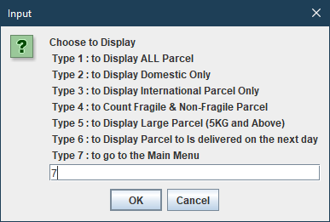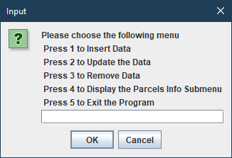

*======End of Output======*

## Appendix 3 : Rubric

**Lab Test Rubric**

**Student Name: ____________________________                                      Section No: ______________**

|  |  |  |  |  |  |
| --- | --- | --- | --- | --- | --- |
| **Criterion** | **% of Grade** | **Excellent (100%)** | **Adequate (80%)** | **Poor (60%)** | **Not Met (0%)** |
| **Program Specifications / Correctness** | 50 | Program works correctly and meets all specification(s).  (41 – 50) | Some program functions work incorrect. Minor details of the program specification are violated.  (31-40) | Significant details of the specification are violated, program often exhibits incorrect behavior.  (21 – 30) | Program only functions correctly in very limited cases or not at all.  (0 – 20) |
| **Marks given** |  |  |  |  |  |
| **Input File** | 10 | The input file is read at the right path as coded in the program and correct data is inserted  (8 – 10) | The input file can be read and but little correct of data inserted  (5 – 7) | Evidence of input file and it cannot be read  (3 – 4) | No evidence of input file and no data is inserted  (0 – 2) |
| **Marks given** |  |  |  |  |  |
| **Readability** | 10 | code is clean, understandable, and well-organized  .  (8 – 10) | Minor issues with consistent indentation, use of whitespace, variable naming, or general organization.  (5 – 7) | At least one major issue with indentation, whitespace, variable names, or organization.  (3 – 4) | Major problems with at three or four of the readability subcategories.  (0 – 2) |
| **Marks given** |  |  |  |  |  |
| **Code Efficiency** | 10 | No errors, code uses the best approach in every case.  (8 – 10) | No error. Acceptable approach of code use*.*  (5 – 7) | Code uses poorly-chosen approaches in at least one place.  (3 – 4) | Code uses poorly-chosen approaches in all places.   (0 – 2) |
| **Marks given** |  |  |  |  |  |
| **Internal Documentation** | 10 | code is well- meaningful commented  (8 – 10) | code is *overly* commented.  (5 – 7) | code is lacking meaningful comments.  (3 – 4) | *un*commented very *lack* comment  (0 – 2) |
| **Marks given** |  |  |  |  |  |
| **Output** | 10 | Full correct output was described  (8 – 10) | Little correct evidence was described  (5 – 7) | Incorrect output  (3 – 4) | No evidence and testing section  (0 – 2) |
| **Marks given** |  |  |  |  |  |
| **Total** |  | **/ 100%** | | | |
| **Comment** |  | | | | |